**Café Aroma - Local Business Homepage**

Submitted by: M Manvanth, Shaun Joshua Alfred, Kevin Richaard G, Jason Antony  
  
Roll Number: 2463037, 2463053, 2463034, 2463025  
  
Course: UI/UX Design Fundamentals  
  
Instructor: Dhiraj  
  
Institution: Christ University  
  
Date: 13/08/2025

**Abstract**

This project focuses on creating a homepage for Café Aroma, showcasing menu items, testimonials, and contact information. The site aims to attract customers through an appealing design and clear presentation of offerings, built with HTML5 and CSS3.

**Objectives**

* Design a visually engaging homepage for a local café
* Showcase menu items with images
* Include testimonials and contact info
* Use HTML and CSS without backend

**Scope of the Project**

* Front-end design only
* Responsive layout for multiple devices
* No backend integration

**Tools & Technologies Used**

|  |  |
| --- | --- |
| **Tool/Technology** | **Purpose** |
| HTML5 | Markup and content structure |
| CSS3 | Styling and layout |
| VS Code | Code editor |
| Chrome DevTools | Testing and debugging |

**HTML Structure Overview**

* Semantic tags like <header>, <nav>, <section>, <footer>
* Sections for Menu, Testimonials, Contact

**CSS Styling Strategy**

* Grid layout for menu
* Flexbox for testimonials
* Media queries for responsiveness

**Key Features**

|  |  |
| --- | --- |
| **Feature** | **Description** |
| Attractive Header | Background image with welcoming text |
| Menu Cards | Visual menu with descriptions |
| Customer Testimonials | Feedback from clients |
| Google Map | Location embedding |

**Challenges Faced & Solutions**

* Image scaling for mobile – resolved with object-fit and responsive grid

**Outcome**

* A functional, responsive homepage for Café Aroma

**Future Enhancements**

* Add JavaScript animations
* Online ordering functionality

**Sample Code**

<!DOCTYPE html>  
<html lang="en">  
<head>  
<meta charset="UTF-8">  
<meta name="viewport" content="width=device-width, initial-scale=1.0">  
<title>Café Aroma - Freshly Brewed Happiness</title>  
<style>  
body {margin:0; font-family: 'Segoe UI', sans-serif; background-color: #fff8f0; color: #333;}  
header {background: url('https://images.unsplash.com/photo-1509042239860-f550ce710b93?auto=format&fit=crop&w=1600&q=80') no-repeat center/cover; height: 80vh; color: white; display: flex; flex-direction: column; justify-content: center; align-items: center; text-align: center;}  
header h1 {font-size: 3rem; background: rgba(0,0,0,0.5); padding: 10px 20px; border-radius: 8px;}  
header p {font-size: 1.2rem; background: rgba(0,0,0,0.4); padding: 5px 15px; border-radius: 6px; margin-top: 10px;}  
nav {background: #5c3d2e; padding: 10px; text-align: center;}  
nav a {color: white; margin: 0 15px; text-decoration: none; font-weight: bold;}  
nav a:hover {text-decoration: underline;}  
section {padding: 50px 20px; max-width: 1100px; margin: auto;}  
.menu-items {display: grid; grid-template-columns: repeat(auto-fit, minmax(250px, 1fr)); gap: 20px;}  
.menu-card {background: white; padding: 15px; border-radius: 8px; box-shadow: 0 4px 10px rgba(0,0,0,0.1); text-align: center;}  
.menu-card img {width: 100%; height: 180px; object-fit: cover; border-radius: 8px;}  
.menu-card h3 {margin: 10px 0 5px;}  
.testimonials {display: flex; flex-wrap: wrap; gap: 20px; justify-content: center;}  
.testimonial {background: #fff; padding: 20px; border-radius: 8px; box-shadow: 0 3px 8px rgba(0,0,0,0.1); max-width: 300px;}  
footer {background: #5c3d2e; color: white; padding: 20px; text-align: center;}  
.contact {display: flex; flex-wrap: wrap; gap: 20px; justify-content: center; align-items: center;}  
.contact iframe {border-radius: 8px;}  
@media (max-width: 768px) {header h1 {font-size: 2rem;}}  
</style>  
</head>  
<body>  
<nav>  
<a href="#menu">Menu</a>  
<a href="#testimonials">Testimonials</a>  
<a href="#contact">Contact</a>  
</nav>  
<header>  
<h1>Welcome to Café Aroma</h1>  
<p>Freshly brewed coffee, delicious pastries, and a warm atmosphere</p>  
</header>  
<section id="menu">  
<h2>Our Special Menu</h2>  
<div class="menu-items">  
<div class="menu-card">  
<img src="https://images.unsplash.com/photo-1517685352821-92cf88aee5a5?auto=format&fit=crop&w=800&q=80" alt="Latte">  
<h3>Caramel Latte</h3>  
<p>Rich espresso with creamy milk and caramel drizzle</p>  
</div>  
<div class="menu-card">  
<img src="https://images.unsplash.com/photo-1509440159596-0249088772ff?auto=format&fit=crop&w=800&q=80" alt="Croissant">  
<h3>Butter Croissant</h3>  
<p>Flaky, buttery goodness baked fresh every morning</p>  
</div>  
<div class="menu-card">  
<img src="https://images.unsplash.com/photo-1517685352821-92cf88aee5a5?auto=format&fit=crop&w=800&q=80" alt="Mocha">  
<h3>Chocolate Mocha</h3>  
<p>A blend of espresso, chocolate, and steamed milk</p>  
</div>  
</div>  
</section>  
<section id="testimonials">  
<h2>What Our Customers Say</h2>  
<div class="testimonials">  
<div class="testimonial">  
<p>“The best coffee in town! I love the cozy vibe and friendly staff.”</p>  
<strong>- Sarah J.</strong>  
</div>  
<div class="testimonial">  
<p>“Their croissants are heavenly. Highly recommend Café Aroma!”</p>  
<strong>- Mark T.</strong>  
</div>  
</div>  
</section>  
<section id="contact">  
<h2>Contact Us</h2>  
<div class="contact">  
<div>  
<p>Email: contact@cafearoma.com</p>  
<p>Phone: +91 98765 43210</p>  
</div>  
<iframe src="https://www.google.com/maps/embed?pb=!1m18!1m12!1m3!1d3153.085127482932!2d-122.40140728468155!3d37.793617879756554!2m3!1f0!2f0!3f0!3m2!1i1024!2i768!4f13.1!3m3!1m2!1s0x80858064a7f3a6e7%3A0xdeb0e3b2a644d5ec!2sBlue%20Bottle%20Coffee!5e0!3m2!1sen!2sus!4v1615403158641!5m2!1sen!2sus" width="300" height="200" style="border:0;" allowfullscreen="" loading="lazy"></iframe>  
</div>  
</section>  
<footer>  
&copy; 2025 Café Aroma. All Rights Reserved.  
</footer>  
</body>  
</html>

**Screenshots of Final Output**

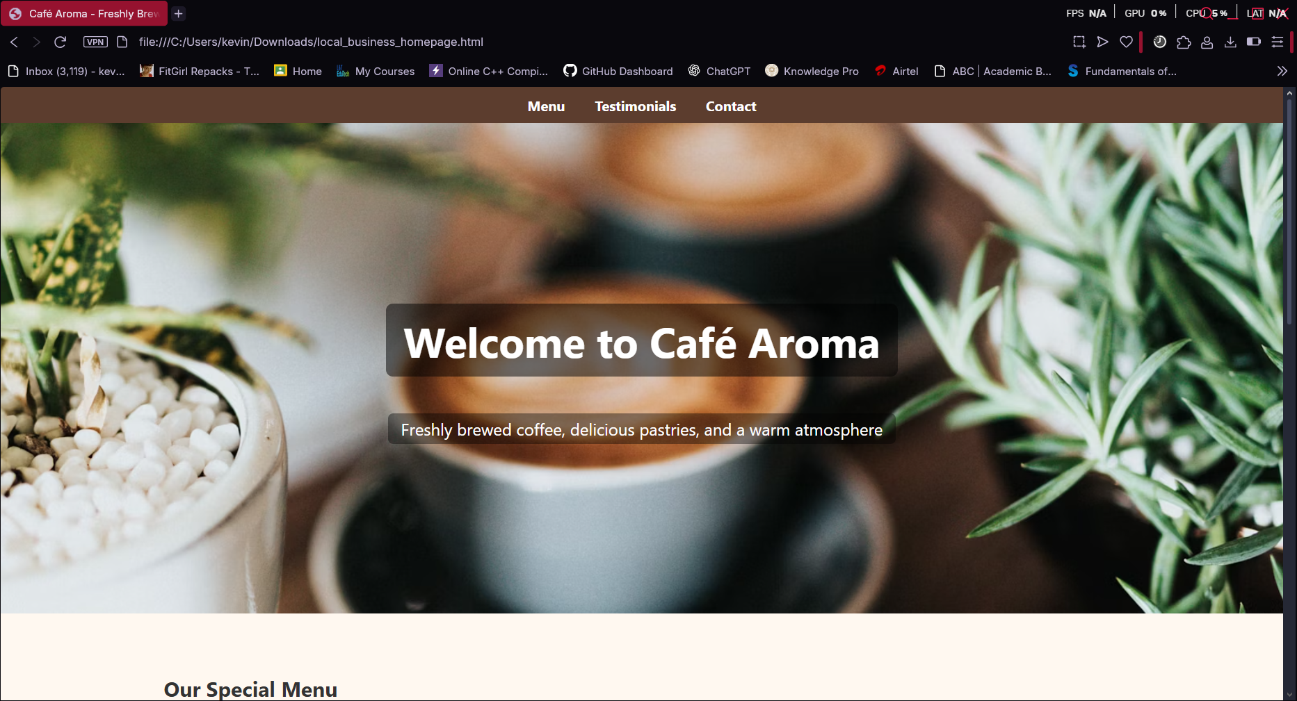

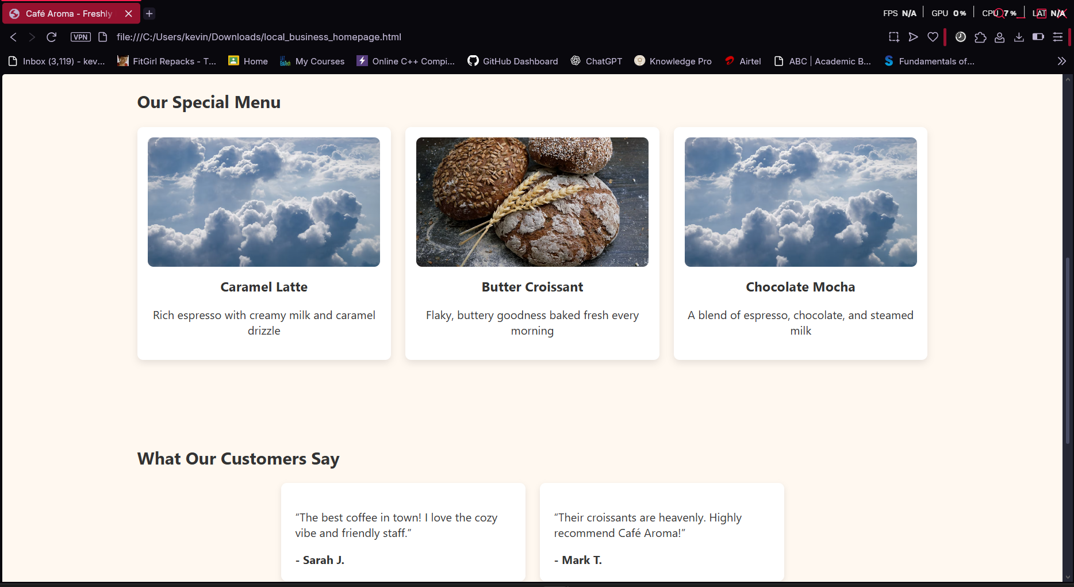

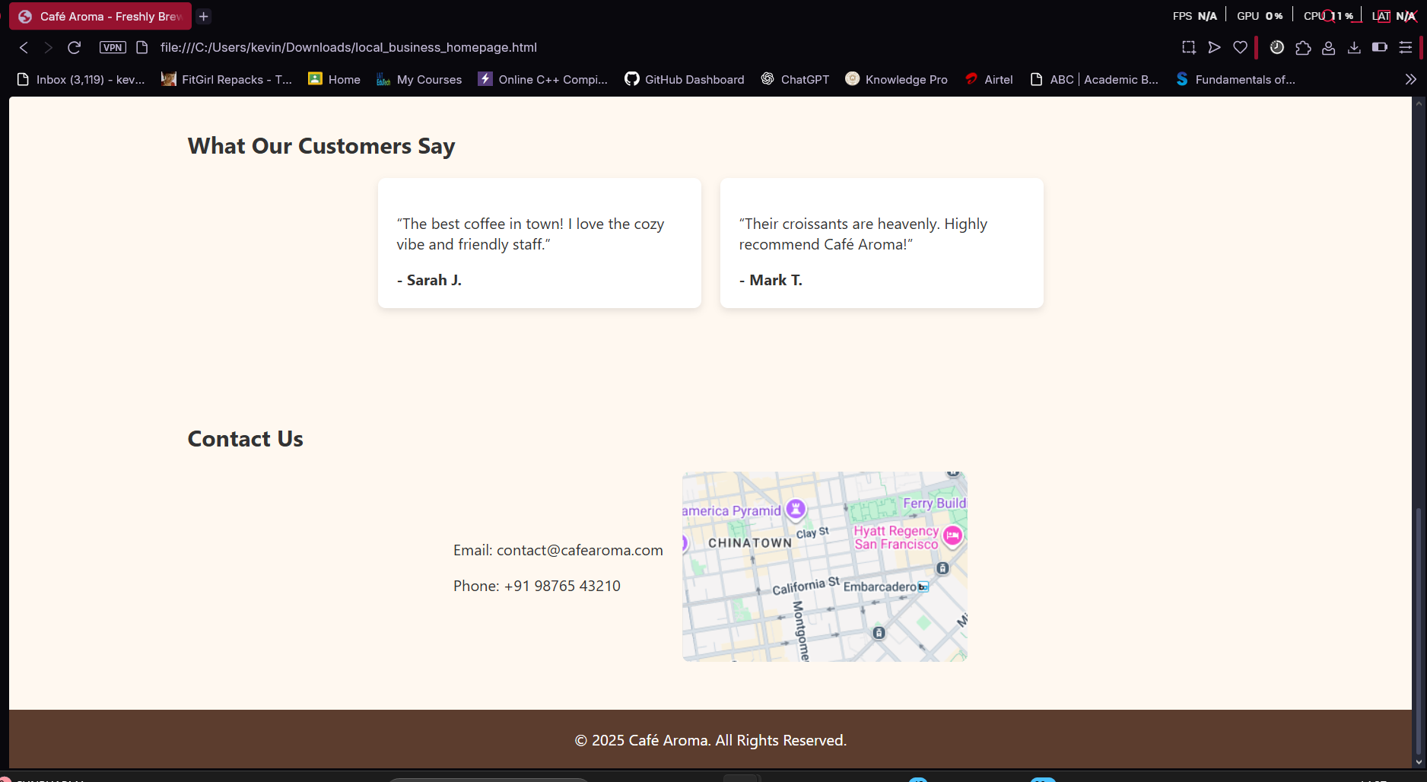

**Conclusion**

This project enhanced my skills in designing small business websites and improved my understanding of responsive layouts.

**References**

* L&T LMS : <https://learn.lntedutech.com/Landing/MyCourse>
* CSS Guide/HTML
* W3schools